**Robot, vriend of vijand?**

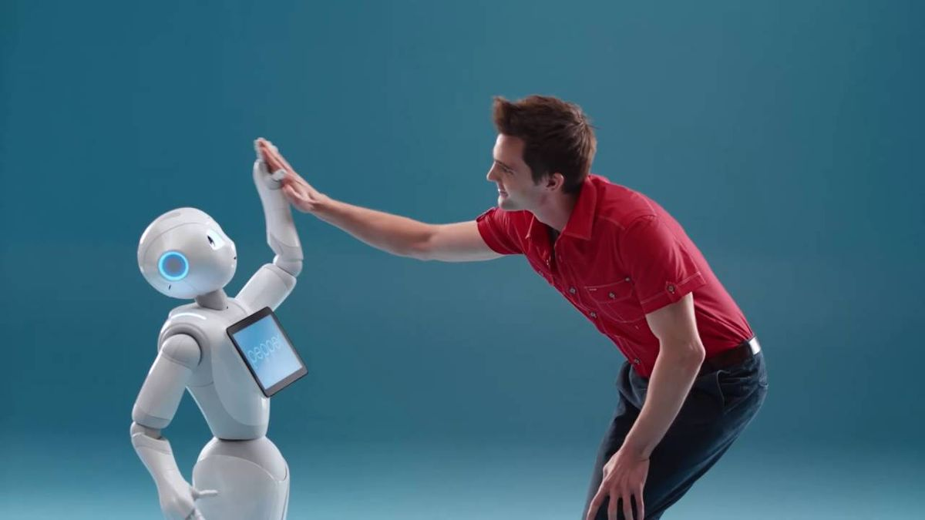

|  |  |
| --- | --- |
| **Wie** |  |
| **Wat** |  |
| **Waar** |  |
| **Wanneer** |  |
| **Hoe** |  |
| **Waarom** |  |
|  |  |